**Upload Assignment: Lab 3 JS DOM 10/08/17**

Assignment Information

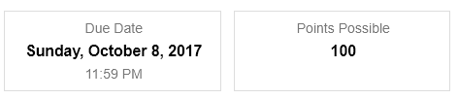

Under the JavaScript tutorial at w3schools, there are the Language, Objects, Function and Forms tabs. We have covered examples of these elements. You should refer to your book and tabs at the site if you need further practice.

This week, I would like you to look at the tab with the JS HTML DOM from the DOM intro to DOM navigation.

https://www.w3schools.com/js/default.asp

Run the examples. Copy the code to files. Make sure they run on your desktop. Zip them and submit them here. Send the appropriate labeled email as well.

